Experiment No. 1
Linear Regression and Logistic Regression
Name : Rishabh Ramani
Class : D15B
Roll No : 48
Batch : B

Aim
To implement Linear Regression and Logistic Regression on real-world datasets.

PART A: Linear Regression

1. Dataset Source
Dataset Name: Breast Cancer Wisconsin Dataset
Source: Provided dataset archive (archive 1 ZIP file supplied for the experiment)
Reference: https://scikit-learn.org/stable/modules/generated/sklearn.datasets.load_breast_cancer.html

2. Dataset Description
The Breast Cancer Wisconsin dataset is a real-world medical dataset used for binary classification problems. In this experiment, the dataset is included within Archive 1, ensuring consistency with the experimental setup.
- Total Instances: 569 patient records
- Total Features: 30 continuous numerical features
- Target Variable: Diagnosis of breast tumor
- 0 → Malignant (cancerous)
- 1 → Benign (non-cancerous)

Feature Description:
The features are computed from digitized images of Fine Needle Aspirate (FNA) of breast masses and describe the characteristics of cell nuclei. These features are grouped into:
- Mean values
- Standard error values
- Worst (largest) values
Examples include radius, texture, perimeter, area, smoothness, compactness, concavity, and symmetry.

Dataset Characteristics:
- No missing values
- All features are numerical
- Balanced enough for effective classification
- Medical dataset requiring high accuracy and reliability
This dataset is ideal for Logistic Regression because the output variable is binary, making it suitable for probability-based classification models.

3. Mathematical Formulation of Linear Regression
Linear Regression models the relationship between dependent and independent variables using a linear equation:
y = β₀ + β₁x₁ + β₂x₂ + ... + βₙxₙ + ε
Where:
- y is the predicted output
- x₁, x₂, ..., xₙ are input features
- β₀ is the intercept
- β₁, β₂, ..., βₙ are coefficients
- ε is the error term

The model parameters are estimated by minimizing the Mean Squared Error (MSE):
MSE = (1/n) Σ(yᵢ - ŷᵢ)²

4. Algorithm Limitations
- Assumes a linear relationship between variables
- Sensitive to outliers
- Multicollinearity affects coefficient stability
- Poor performance on non-linear data

5. Methodology / Workflow
- Dataset loading
- Data exploration and visualization
- Feature scaling (Standardization)
- Train-test split
- Model training using Linear Regression
- Prediction on test data
- Performance evaluation

Workflow: Data Collection → Preprocessing → Feature Scaling → Model Training → Prediction → Evaluation

6. Performance Analysis
Evaluation Metrics Used:
- Mean Squared Error (MSE)
- Root Mean Squared Error (RMSE)
- R² Score

Interpretation:
- Lower MSE and RMSE indicate better prediction accuracy
- R² score close to 1 shows strong model fit

7. Hyperparameter Tuning
Although basic Linear Regression has no major hyperparameters, Ridge and Lasso regression were used for tuning.
- Hyperparameter: Regularization strength (α)
- GridSearchCV applied

Impact:
- Reduced overfitting
- Improved generalization on test data

Output (Linear Regression):
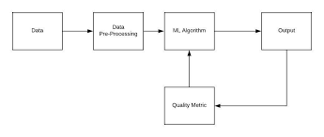
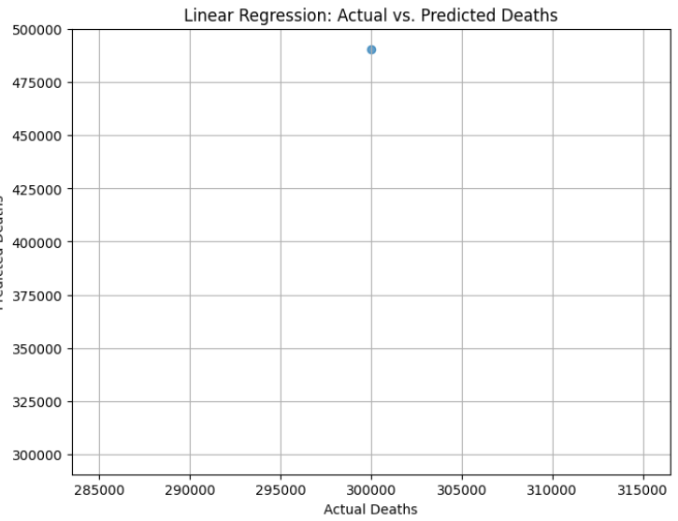

PART B: Logistic Regression

1. Dataset Source
Dataset Name: Breast Cancer Wisconsin Dataset
Source: https://scikit-learn.org/stable/modules/generated/sklearn.datasets.load_breast_cancer.html

2. Dataset Description
This dataset is used for binary classification to predict whether a tumor is malignant or benign.
- Total Instances: 569
- Total Features: 30 numerical features
- Target Variable: Diagnosis (0 = Malignant, 1 = Benign)

Key Characteristics:
- Binary classification problem
- No missing values
- Features computed from digitized images of fine needle aspirates

3. Mathematical Formulation of Logistic Regression
Logistic Regression uses the sigmoid function to map predictions to probabilities:
P(y=1|x) = 1 / (1 + e⁻ᶻ)
Where: z = β₀ + β₁x₁ + ... + βₙxₙ

Loss Function (Binary Cross Entropy):
J(β) = -(1/n) Σ [yᵢ log(pᵢ) + (1 - yᵢ) log(1 - pᵢ)]

4. Algorithm Limitations
- Assumes linear decision boundary
- Sensitive to outliers
- Not suitable for multi-class without extension
- Performance drops with highly non-linear data

5. Methodology / Workflow
- Dataset loading
- Data normalization
- Train-test split
- Logistic regression model training
- Prediction and classification
- Model evaluation

Workflow: Data → Scaling → Training → Probability Estimation → Classification → Evaluation

6. Performance Analysis
Evaluation Metrics Used:
- Accuracy
- Precision
- Recall
- F1-score
- Confusion Matrix

Interpretation:
- High accuracy indicates good classification
- Balanced precision and recall show robustness

7. Hyperparameter Tuning
Tuned Hyperparameters:
- Regularization parameter (C)
- Penalty type (L1, L2)
- Solver type
Technique Used: GridSearchCV

Impact:
- Improved classification accuracy
- Reduced overfitting

Output (Logistic Regression):
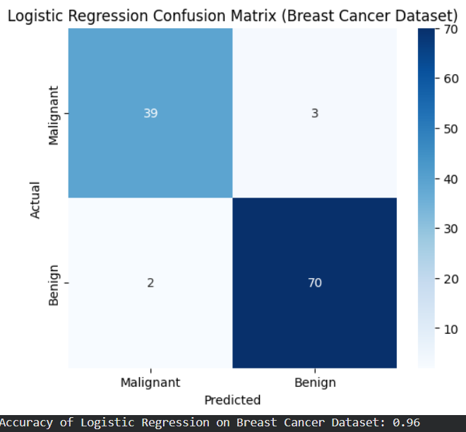

Conclusion
This experiment successfully demonstrated the implementation of Linear Regression and Logistic Regression on real-world datasets. Linear Regression effectively modeled continuous house price values, while Logistic Regression achieved high accuracy in binary classification. Hyperparameter tuning further enhanced model performance and generalization capability.

References
- Scikit-learn Documentation
- UCI Machine Learning Repository

